EXP 2: Simulation and Performance
Evaluation of People–Process–Data–Things IoE Framework using Edge/Fog-to-Cloud Pipeline

Objective: To simulate and evaluate a People–Process–Data–Things (PPDT) Internet of Everything (IoE) framework using an Edge/Fog-to-Cloud pipeline to improve data processing efficiency, reduce latency, optimize bandwidth usage, and enhance system performance, reliability, and scalability.
Procedure:
- Design the PPDT-based IoE framework.
- Simulate IoE devices generating real-time data.
- Process data at the Edge and Fog layers.
- Transfer processed data to the Cloud for storage and analysis.
- Evaluate latency, throughput, bandwidth, and energy efficiency.
- Compare the results with a cloud-only approach.
- Analyze the results to assess overall system performance.

Number of sources: 50
 | Edge | Fog | Cloud
Propagation delay | 50 | 250 | 1000
Processing delay | 100 | 200 | 400
Queueing delay | 25 | 75 | 150
End to end | 176.16 ms | 526.16 ms | 1551.16 ms
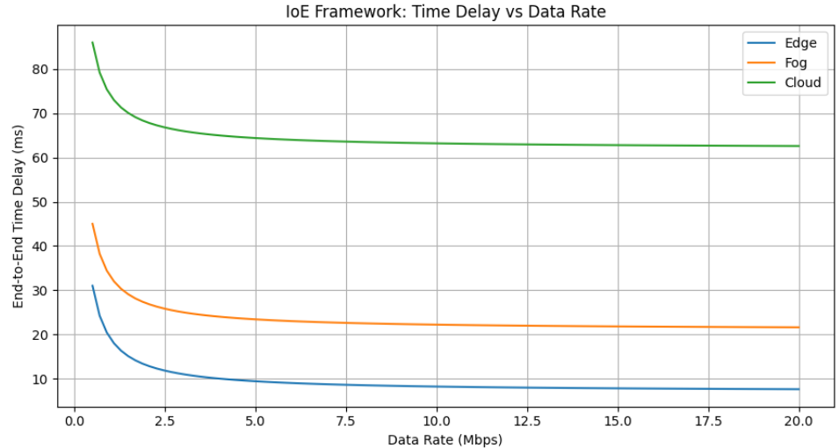
Number of sources: 100
 | Edge | Fog | Cloud
Propagation delay | 100 | 500 | 2000
Processing delay | 200 | 400 | 800
Queueing delay | 50 | 150 | 300
End to end | 351.16 ms | 1051.16 ms | 3101.16 ms

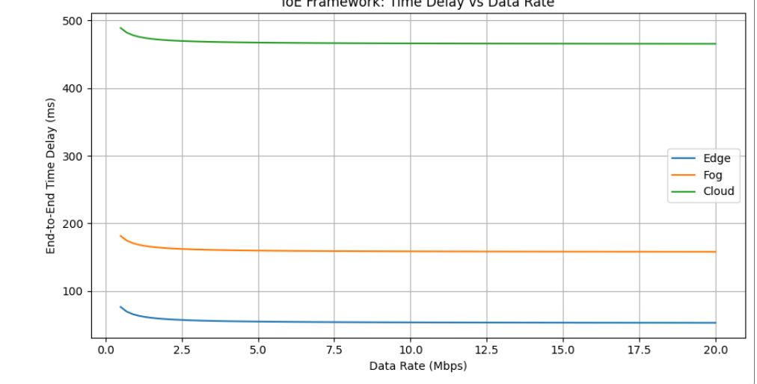
Result:
Edge computing provides the lowest end-to-end delay compared to Fog and Cloud for both 50 and 100 sources (176.16 ms vs 526.16 ms vs 1551.16 ms for 50 sources, and 351.16 ms vs 1051.16 ms vs 3101.16 ms for 100 sources). As the number of sources doubles from 50 to 100, the delay of every layer roughly doubles, and Cloud shows the largest absolute increase. Therefore, Edge is best for real-time IoE applications, Fog provides moderate performance, and Cloud is suitable for large-scale data processing where delay is less critical.

